
Subject: Programming with Java
ASSIGNMENT 4

TITLE: Develop a Java application demonstrating the use of wrapper classes for conversion
between primitive data types and objects, and performing basic operations on wrapped values.

Problem Statement:
Develop a Java application demonstrating the use of wrapper classes for conversion between
primitive data types and objects, and performing basic operations on wrapped values.

Learning Objectives:
To perform conversion between primitive data types and wrapper objects using Java wrapper
classes.

Theory:
Wrapper classes are predefined classes that encapsulate primitive data types into objects. Java provides wrapper classes such as Integer, Double, Character, and Boolean for every primitive type. They support autoboxing, unboxing, parsing, and conversion methods. Wrapper classes are widely used in Java Collections Framework and when object representation of primitive values is required.

Source Code:
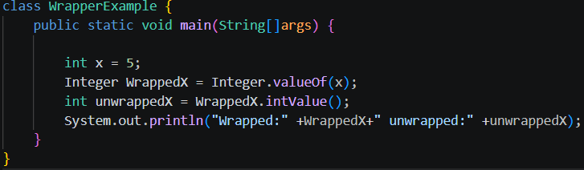

Program Outcome:
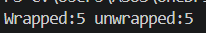

Conclusion:
The program successfully demonstrates the use of Java wrapper classes to convert primitive data types and String values into wrapper objects. It also performs basic operations such as parsing, validation, and arithmetic calculations on the wrapped values. Thus, the application helps in understanding the importance and practical use of wrapper classes in Java programming.

Exercise
1.Create a program to convert student marks from String format to Integer and calculate total marks.

Source Code:
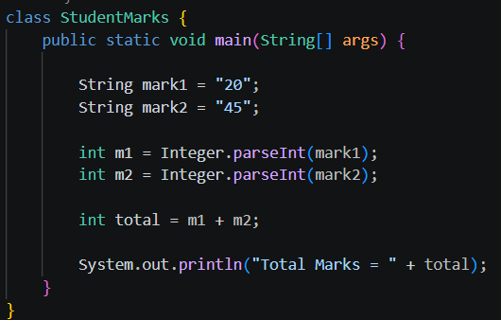

Program Outcome:

2. Develop an Employee Payroll System that accepts employee IDs, basic salary, and bonus
amounts from the user. Convert the entered values into wrapper objects and perform validation operations to ensure valid salary values before calculating the net salary.
Source Code:
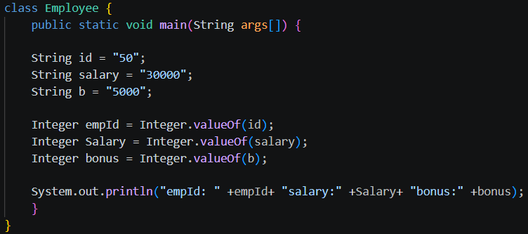
Program Outcome:

